**ASSIGNMENTS ON DIGITAL MARKETING**

**NAME:** K. R. AKILAN

**DEPARTMENT:** COMPUTER SCIENCE AND ENGINEERING

**COLLEGE:** 8151 DHANALAKSHMI SRINIVASAN INSTITUTE OF

TECHNOLOGY .

**NAANMUDHALVAN COURSE**: DIGITAL MARKETING

**NM ID: 0327A3CEB1029718A5F4E8DE5B4AFDC7**

**ASSIGNMENT 1:**

Create a blog or website using Blogspot and WordPress. Customize

The theme design and post new article with 500 words.

[**www.petzmedia.blogspot.com/**](http://www.petzmedia.blogspot.com/)

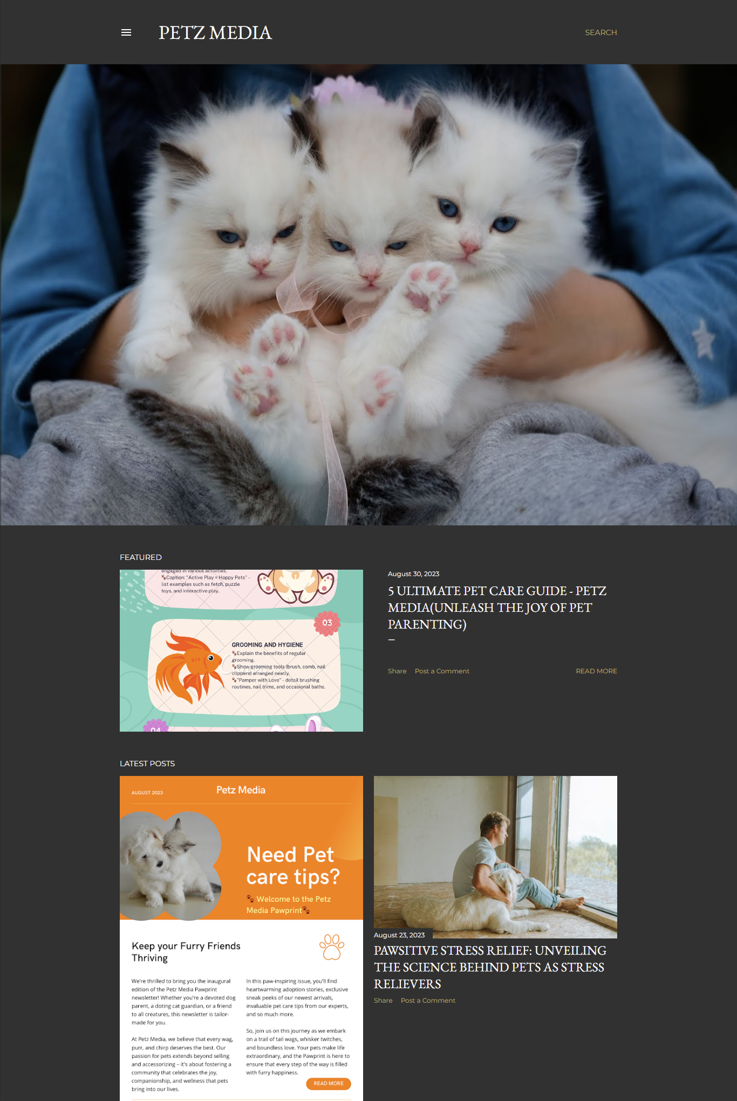

**ASSIGNMENT 2:**

Create a new Facebook business Page and Post one social media poster for your brand.

[**www.facebook.com/petzmedia**](http://www.facebook.com/petzmedia)

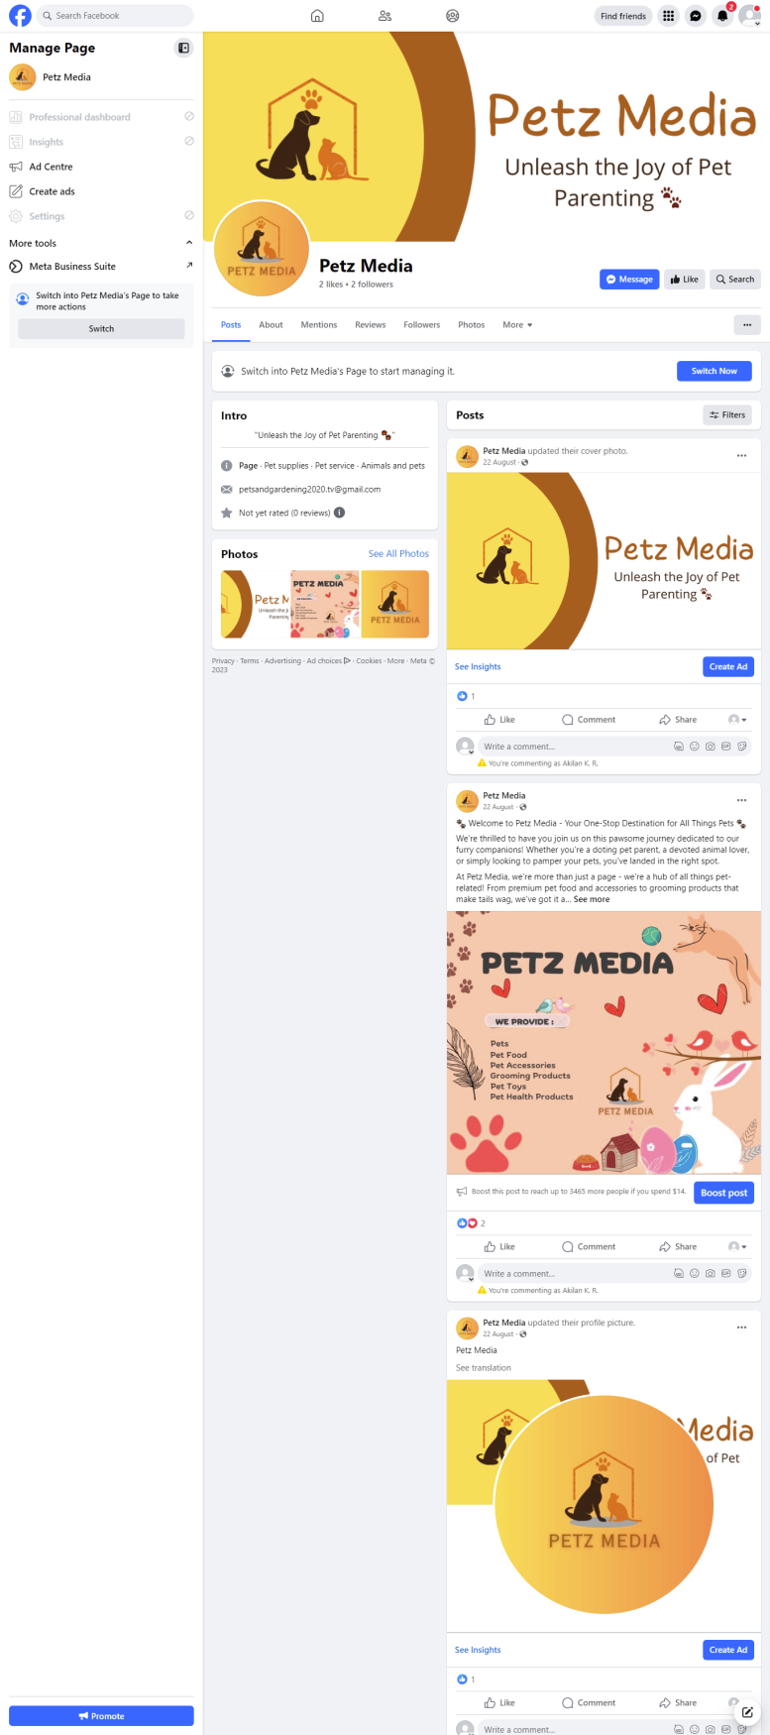

**ASSIGNMENT 3:**

Create and design a social media advertisement poster using Canva.

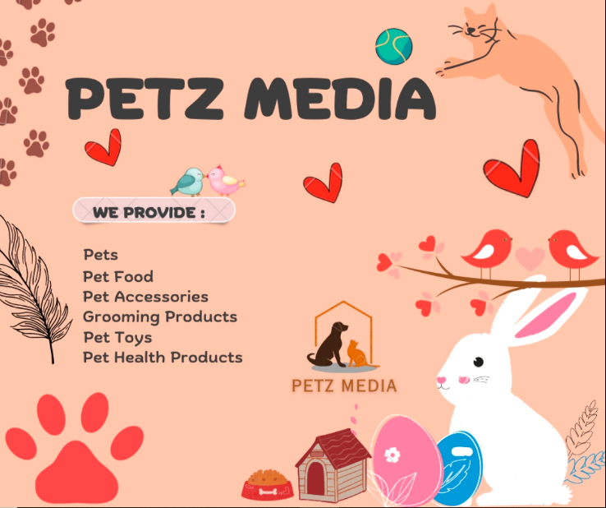

**ASSIGNMENT 4:**

Create email newsletter design using MailChimp or Canva tool.

[**www.petzmedia.blogspot.com/2023/08/email-news-letter-petz-mediaunleash-joy.html**](http://www.petzmedia.blogspot.com/2023/08/email-news-letter-petz-mediaunleash-joy.html)

